

**Information Technology University (ITU)**

Software Requirement Specification  
(SRS DOCUMENT)

for

**Hair Rescue Hub**  
Version 1.0

***By***

**M.Abubakar Saif BSCE21017**

**Saud Sohail BSCE21022**

**Musa Zaheer BSCE21037**

***Supervisor*Dr Usman Younis**

***Co-Supervisor*Ayesha Aman**

*Bachelor of Science in Computer Engineering(2021-2025)*

**Table of Contents**

1. Introduction 1

1.1 Purpose 1

1.2 Scope 1

1.3 Modules 1

2. Overall Description 2

2.1 Product Perspective 2

2.2 User classes and characteristics 2

2.3 Operating Environment 2

2.4 Design and Implementation Constraints 2

3. Requirement Identifying Technique 3

4. Functional Requirements 3

4.1 Free tips & tutorials 3

4.2 Time-Saving Convenience 3

4.3 Authentic Product 4

4.4 AI chat bot/real-time feedback 4

4.5 Online consultations 5

5. Non-Functional Requirements 5

5.1 Reliability 5

5.2 Usability 5

5.3 Performance 6

5.4 Security  6

6. External Interface Requirements 6

6.1 User Interfaces Requirements 6

6.2 Software interfaces 7

6.3 Hardware interfaces 7

6.4 Communications interfaces 7

7. References 7

# Introduction

Hair loss and related concerns affect a significant portion of the global population, with more than 80% of men and nearly half of women experiencing significant hair loss during their lifetime. Despite the prevalence of these issues, finding a comprehensive and personalized solution remains a challenge. Hair loss can have profound emotional and social impacts, leading to decreased self-esteem, social anxiety, and even affecting one's professional image and success, especially in appearance-conscious fields.

In response to these challenges, we are introducing "Hair Rescue Hub," an innovative application aimed at addressing hair-related problems. Hair Rescue Hub goes beyond traditional treatments by providing a holistic approach to hair care. Through a combination of expert guidance, personalized solutions, and user-friendly features, Hair Rescue Hub empowers individuals to take control of their hair health effectively.

## Purpose

The purpose of "Hair Rescue Hub" is to provide a comprehensive and personalized solution to address hair-related problems effectively. By offering expert guidance, personalized solutions, and user-friendly features, the application aims to empower individuals to regain control over their hair health and overcome the emotional and social challenges associated with hair loss. Through innovative approaches and accessible resources, Hair Rescue Hub seeks to improve the overall well-being and confidence of its users.

## Scope

The scope of "Hair Rescue Hub" encompasses a wide range of features and functionalities aimed at addressing various hair-related concerns comprehensively. This includes providing expert guidance, personalized solutions, and user-friendly features to empower individuals in managing and improving their hair health. Additionally, the application will offer resources such as tips, tutorials, treatment schedules, home remedies, and real-time feedback through an AI chatbot. The scope also extends to facilitating video consultations with healthcare professionals, enhancing accessibility and convenience for users seeking expert advice. Overall, Hair Rescue Hub aims to cater to the diverse needs of individuals experiencing hair loss or related issues, ensuring a holistic approach to hair care within a unified platform.

## Modules

Discover the diverse range of modules within Hair Rescue Hub, each meticulously designed to cater to your specific hair care needs and empower you on your journey to healthier, more vibrant hair. Our system will have:

* Expert Guidance
* Personalized Solutions
* User-Friendly Features
* Educational Resources
* Real-Time Feedback
* Treatment Schedule
* Video Consultations
* Community Engagement
* Data Management
* Integration

# Overall Description

This section presents a high-level overview of Hair Rescue Hub and the environment in which it will be used, the anticipated users, and known constraints, assumptions, and dependencies.

## Product Perspective

* **Comprehensive Feature Set:** Hair Rescue Hub incorporates various functionalities such as providing free tips and tutorials, enabling users to organize their treatment schedules, facilitating the purchase of authentic hair products, offering AI chatbot assistance, and facilitating online consultations with healthcare professionals.
* **Integration with Digital Health Landscape:** Positioned within the realm of digital health and wellness applications, Hair Rescue Hub seamlessly integrates with users' lifestyles, offering convenient access to specialized hair care solutions.
* **User-Centric Design:** The platform prioritizes user needs and preferences, delivering personalized solutions tailored to individual hair care requirements. It ensures ease of use, accessibility, and privacy for users seeking to improve their hair health.
* **Adherence to Industry Standards:** Hair Rescue Hub maintains compliance with industry regulations, emphasizing the authenticity of products, qualifications of healthcare professionals, and data security measures to safeguard user information.
* **Holistic Approach to Hair Care:** By addressing various aspects of hair health, from prevention to treatment, Hair Rescue Hub embodies a holistic approach, empowering users to proactively manage and enhance the vitality of their hair.

## User classes and characteristics

* **General Users:** Individuals seeking solutions for hair fall, hair damage, and related concerns.
* **Busy Professionals:** Working individuals, like Ahmed, who require convenient and time-saving solutions.
* **Health-Conscious Consumers:** Users prioritizing health and wellness, seeking expert guidance and verified solutions.
* **Tech-Savvy Individuals:** Comfortable with technology, interested in innovative features like AI chatbots.
* **Beauty and Wellness Enthusiasts:** Passionate about maintaining appearance and well-being.
* **Novice Users:** New to hair care routines, may require additional guidance and educational resources.

## Operating Environment

Hair Rescue Hub operates seamlessly on mobile platforms, catering to both **iOS** and **Android** devices. Users can access the application via smartphones and tablets, provided they have a stable internet connection. The app's interface is designed to be intuitive and user-friendly, ensuring smooth navigation and interaction. Compatibility across various devices ensures accessibility for a wide range of users. Additionally, stringent security measures are in place to safeguard user data, payment transactions, and confidentiality during online consultations.

## Design and Implementation Constraints

* **Platform Limitations:** Hair Rescue Hub must adhere to the guidelines and restrictions imposed by app stores (e.g., Apple App Store, Google Play Store) regarding content, functionality, and user experience.
* **Compatibility Challenges**: Ensuring compatibility with a diverse range of mobile devices, operating systems, and screen sizes presents implementation challenges that require careful consideration during development.
* **Data Privacy Regulations:** Compliance with data privacy laws and regulations, such as GDPR and CCPA, imposes constraints on data collection, storage, and processing practices to protect user privacy.
* **Resource Limitations:** Availability of resources, including time, budget, and technical expertise, may impose constraints on the development process and timeline for implementing new features or updates.
* **Integration Complexity:** Integrating third-party services, such as payment gateways for product purchases or video conferencing platforms for online consultations, may introduce complexities and require thorough testing to ensure seamless functionality.

# Requirement Identifying Technique

This section describes the requirements identifying technique(s) which further help to derive functional requirements specification. The selection of the technique(s) will depend on the type of project. For instance,

* **Use case (use case diagram + detail use case)** is an effective technique for interactive end-user applications.
* **Event- response table** is for real-time system in which most of the functionalities are performed at backend.
* **Storyboarding** for graphically intensive applications.

Examples of above techniques are given in Appendix A

# Functional Requirements

These are the software capabilities that must be implemented for the user to carry out the feature’s services or to perform a use case.

## Free tips & tutorials

|  |  |
| --- | --- |
| **Identifier** | FR-1 |
| **Title** | Free tips & tutorials |
| **Requirement** | Give our users free tips & tutorials on how they can avoid hair fall or hair damage , and recover from this. |
| **Source** | Customer Support Department |
| **Rationale** | Position the platform as a comprehensive resource for users' well-being. |
| **Business Rule** | The content should be evidence-based and endorsed by qualified experts. |
| **Dependencies** | User profile creation and management system to personalize tips based on individual needs. |
| **Priority** | High (This feature aligns with the core value proposition of the platform). |

## Time-Saving Convenience

|  |  |
| --- | --- |
| **Identifier** | FR-2 |
| **Title** | Time-Saving Convenience |
| **Requirement** | There will also be a schedule of treatment organized by the user himself. |
| **Source** | User Feedback and Requests |
| **Rationale** | Empower users to take control of their treatment plans |
| **Business Rule** | Ensure privacy and security of user-created schedules.  The scheduling feature should be intuitive and easy to use. |
| **Dependencies** | Calendar integration or a scheduling module. |
| **Priority** | High (User customization is a key feature for your platform |

## Authentic Product

|  |  |
| --- | --- |
| **Identifier** | FR-3 |
| **Title** | Authentic Product |
| **Requirement** | There will be a hair products purchase section for customers in the app |
| **Source** | E-Commerce Integration Team |
| **Rationale** | Generate additional revenue through product sales. |
| **Business Rule** | Only authentic and approved hair products will be listed.  Secure and reliable payment processing. |
| **Dependencies** | User authentication and payment gateway integration. |
| **Priority** | High (product sales are important for the revenue stream). |

## AI chat bot/real-time feedback

|  |  |
| --- | --- |
| **Identifier** | FR-4 |
| **Title** | AI chat bot/real-time feedback |
| **Requirement** | Real-time feedback and guidance through an AI chat bot, accommodating users busy schedule. |
| **Source** | Customer Support Department |
| **Rationale** | Enhance user experience by providing immediate assistance. |
| **Business Rule** | The AI chatbot should be available 24/7 for real-time assistance. |
| **Dependencies** | AI chatbot system and natural language processing |
| **Priority** | Medium (it's a valuable feature but not central to the platform). |

## Online consultations

|  |  |
| --- | --- |
| **Identifier** | FR-5 |
| **Title** | Online consultations |
| **Requirement** | Conveniently connect with healthcare professionals for personalized advice, taking into account local environmental challenges. |
| **Source** | User Feedback and Requests |
| **Rationale** | Facilitate convenient access to healthcare expertise. |
| **Business Rule** | Healthcare professionals should be verified and licensed. |
| **Dependencies** | Integration with healthcare professionals' profiles and scheduling. |
| **Priority** | Medium (It's a valuable feature but not central to the platform)002 |

# Non-Functional Requirements

This section specifies nonfunctional requirements other than constraints, which are recorded in section 2.3, and external interface requirements, which will appear in section 7. These quality requirements should be specific, quantitative, and verifiable. Chapter 14 “beyond functionality” presents more information about these quality attribute requirements and many examples. The following are some examples of documenting guidelines.

## Reliability

Requirements about how often the software fails. The measurement is often expressed in MTBF (mean time between failures). The definition of a failure must be clear. Also, don't confuse reliability with availability which is quite a different kind of requirement.  Be sure to specify the consequences of software failure, how to protect from failure, a strategy for error detection, and a strategy for correction.

## Usability

Usability requirements deal with ease of learning, ease of use, error avoidance and recovery, the efficiency of interactions, and accessibility. The usability requirements specified here will help the user interface designer create the optimum user experience.

Example:

*USE-1: The COS shall allow a user to retrieve the previous meal ordered with a single interaction.*

## 

## Performance

State specific performance requirements for various system operations. If different functional requirements or features have different performance requirements, it’s appropriate to specify those performance goals right with the corresponding functional requirements, rather than collecting them in this section.

Example:

*PER-1: 95% of webpages generated by the COS shall download completely within 4 seconds from the time the user requests the page over a 20 Mbps or faster Internet connection.*

## Security

One or more requirements about protection of your system and its data. The measurement can be expressed in a variety of ways (effort, skill level, time, ...) to break into the system.  Do not discuss solutions (e.g. passwords) in a requirements document.

# External Interface Requirements

The information provided in this section ensures that the **system** communicates correctly with external components.

## User Interfaces Requirements

***6.1.1 User-friendly Design:***

The UI should be intuitive and user-friendly, catering to users of all ages and technical backgrounds.

***6.1.2 Compatibility:***

The application should be compatible with popular smartphones (iOS and Android) and tablets.

***6.1.3 Accessibility:***

Ensure the UI is accessible to users with disabilities, adhering to accessibility standards.

***6.1.4 Multilingual Support:***

Provide support for multiple languages to accommodate a diverse user base.

***6.1.5 Personalization:***

Allow users to personalize their experience, such as themes or font sizes.

***6.1.6 Interactive Elements:***

Include interactive elements for engaging user experience, such as swipe gestures, buttons, and sliders.

***6.1.7 Feedback Mechanism:***

Implement a feedback mechanism for users to report issues or suggest improvements.

## Software interfaces

***6.2.1 Operating System Compatibility:***

Support the latest versions of iOS and Android operating systems, ensuring regular updates for compatibility with new releases.

***6.2.2 Third-party Integrations:***

Integrate with external systems or APIs for features like video consultations or AI chatbot functionalities.

***6.2.3 Data Storage:***

Specify the database system used for storing user data, ensuring security and compliance with data protection regulations.

***6.2.4 Cloud Services:***

If applicable, specify the use of cloud services for scalability and efficient data management.

***6.2.5 Security Protocols:***

Implement secure communication protocols to protect user data during transmission.

## Hardware interfaces

***6.3.1 Device Compatibility:***

The app should run seamlessly on a range of devices, ensuring compatibility with various screen sizes and resolutions.

***6.3.2 Camera Integration:***

If video consultations are supported, integrate with the device's camera for video calls.

***6.3.3 Sensor Integration:***

Utilize device sensors (e.g., gyroscope) for features like augmented reality (AR) or personalized experiences.

## Communications interfaces

***6.4.1 In-app Messaging:***

Provide an in-app messaging system for users to communicate with healthcare professionals or support.

***6.4.2 Push Notifications:***

Implement push notifications for important updates, reminders, or new content.

***6.4.3 Video Consultation Interface:***

If video consultations are supported, ensure a stable and secure interface for real-time video communication.

***6.4.4 API Documentation:***

If exposing APIs for third-party integrations, provide comprehensive documentation for developers.

***6.4.5 Chatbot Integration:***

If using AI chatbot, ensure seamless integration within the app for real-time feedback and assistance.

# References

List any documents or other resources to which this SRS refers, if any. These might include user interface style guides, standards, system requirements specifications, interface specifications, or the SRS for a related product. The following are a few examples of different resources.

**Book**

Author(s). Book title. Location: Publishing company, year, pp.

Example:

W.K. Chen. Linear Networks and Systems. Belmont, CA: Wadsworth, 1993, pp. 123-35.

**Article in a Journal**

Author(s). “Article title”. Journal title, vol., pp, date.

Example:

G. Pevere. “Infrared Nation.” The International Journal of Infrared Design, vol. 33, pp. 56-99, Jan. 1979.

**Articles from Conference Proceedings (published)**

Author(s). “Article title.” Conference proceedings, year, pp.

Example:

D.B. Payne and H.G. Gunhold. “Digital sundials and broadband technology,” in Proc. IOOC-ECOC, 1986, pp. 557-998.

**World Wide Web**

Author(s)*. “Title.” Internet: complete URL, date updated* [date accessed].

M. Duncan. “Engineering Concepts on Ice. Internet: www.iceengg.edu/staff.html, Oct. 25, 2000 [Nov. 29, 2003].

**Appendix A**

**Example: Context Diagram**

The Cafeteria Ordering System is a new software system that replaces the current manual and telephone processes for ordering and picking up meals in the Process Impact cafeteria. The context diagram in Figure A-1 illustrates the external entities and system interfaces.

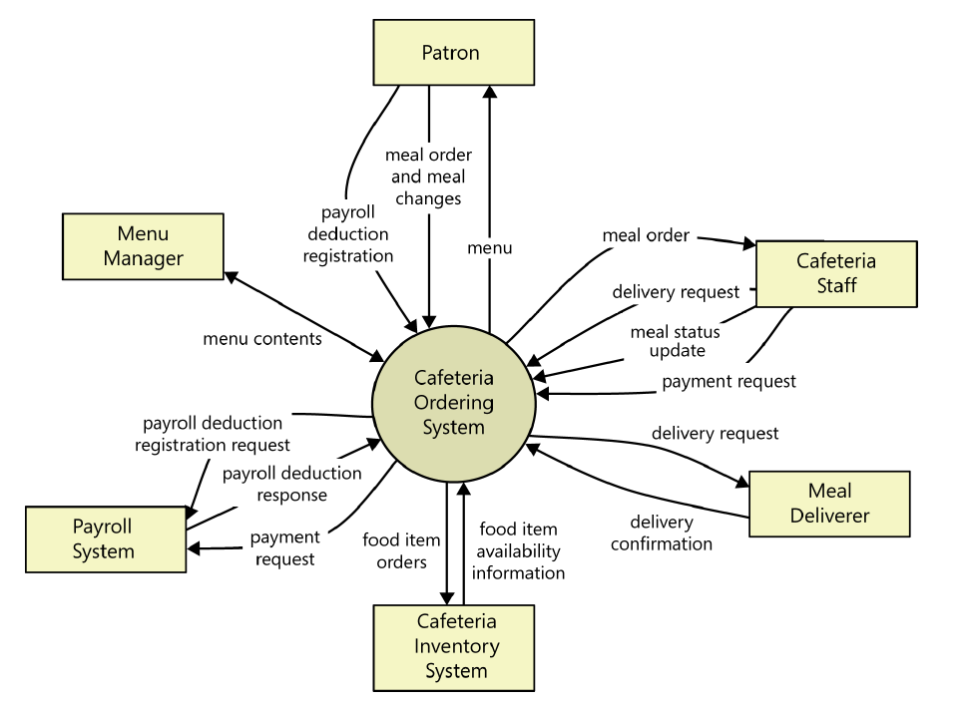

Figure A-1: Context diagram of the Cafeteria Ordering System.

**Example: User Classes and Characteristics**

Table A-1 Shows user classes and characteristic for Cafetaria ordering system

|  |  |
| --- | --- |
| **User class** | **Description** |
| **Patron** | A Patron is a Process Impact employee who wants to order meals to be delivered from the company cafeteria. There are about 600 potential Patrons, of which 300 are expected to use the COS an average of 5 times per week each. Patrons will sometimes order multiple meals for group events or guests. An estimated 60 percent of orders will be placed using the corporate intranet, with 40 percent of orders being placed from home or by smartphone or tablet apps. |
| **Cafeteria Staff** | The Process Impact cafeteria employs about 20 Cafeteria Staff who will receive orders from the COS, prepare meals, package them for delivery, and request delivery. Most of the Cafeteria Staff will need training in the use of the hardware and software for the COS. |
| **Menu Manager** | The Menu Manager is a cafeteria employee who establishes and maintains daily menus of the food items available from the cafeteria. Some menu items may not be available for delivery. The Menu Manager will also define the cafeteria’s daily specials. The Menu Manager will need to edit existing menus periodically. |
| **Meal Deliverer** | As the Cafeteria Staff prepare orders for delivery, they will issue delivery requests to a Meal Deliverer’s smartphone. The Meal Deliverer will pick up the food and deliver it to the Patron. A Meal Deliverer's other interactions with the COS will be to confirm that a meal was (or was not) delivered. |

**Example: Use case Diagram**

Following use case diagram is of an appointment system in which all the use case diagram relationships are presented. In further in **Table A-2** to the detail of use case diagram sytax is provided.

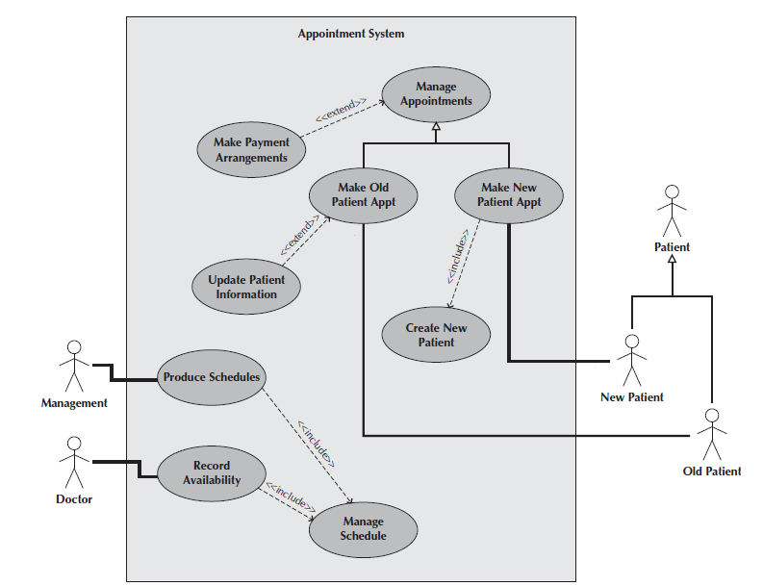

Figure A-2: Use Case Diagram of an Appointment System

**Syntax for Use case Diagram**

Table A-2 Syntax for Use case Diagram

|  |  |
| --- | --- |
| **An actor:**  ■ Is a person or system that derives benefit from and is external to the subject.  ■ Is depicted as either a stick figure (default) or, if a nonhuman actor is involved, a  rectangle with <<actor>> in it (alternative).  ■ Is labeled with its role.  ■ Can be associated with other actors using a specialization/superclass association,  denoted by an arrow with a hollow arrowhead.  ■ Is placed outside the subject boundary. |  |
| **A use case:**  ■ Represents a major piece of system functionality.  ■ Can extend another use case.  ■ Can include another use case.  ■ Is placed inside the system boundary.  ■ Is labeled with a descriptive verb–noun phrase. |  |
| **subject boundary:**  ■ Includes the name of the subject inside or on top.  ■ Represents the scope of the subject, e.g., a system or an individual  business process. |  |
| **An association relationship:**  ■ Links an actor with the use case(s) with which it interacts. |  |
| **An include relationship:**  ■ Represents the inclusion of the functionality of one use case within another.  ■ Has an arrow drawn from the base use case to the used use case. |  |
| **An extend relationship:**  ■ Represents the extension of the use case to include optional behavior.  ■ Has an arrow drawn from the extension use case to the base use case. |  |
| **A generalization relationship:**  ■ Represents a specialized use case to a more generalized one.  ■ Has an arrow drawn from the specialized use case to the base use case. |  |

**Detail Use Case Example**

The below indicate a comprehensive use case template filled in with an example drawn from the Cafeteria ordering system (COS).

**UC-1: Order a Meal**

[Provide a brief description of the reason for and outcome of this use case.] e.g.

In this use case a Patron accesses the Cafeteria Ordering System from either the corporate intranet or external Internet, views the menu for a specific date, selects food items, and places an order for a meal to be picked up in the cafeteria or delivered to a specified location within a specified 15-minute time window

|  |  |  |  |  |  |
| --- | --- | --- | --- | --- | --- |
| **Actors:** | [An actor is a person or other entity external to the software system being specified who interacts with the system and performs use cases to accomplish tasks.] e.g.   |  |  |  |  | | --- | --- | --- | --- | | Primary Actor: | Patron | Secondary Actors: | Cafeteria Inventory System | |
| **Trigger:** | [Identify the event that initiates the use case.]e.g.  A Patron indicates that he wants to order a meal. |
| **Preconditions:** | [List any activities that must take place, or any conditions that must be true, before the use case can be started.  PRE-1. Patron is logged into COS.  PRE-2. Patron is registered for meal payments by payroll deduction. |
| **Postconditions:** | [Describe the state of the system at the conclusion of the use case execution.  POST-1. Meal order is stored in COS with a status of “Accepted.”  POST-2. Inventory of available food items is updated to reflect items in this order.  POST-3. Remaining delivery capacity for the requested time window is updated. |
| **Normal Flow:** | [Provide a detailed description of the user actions and system responses that will take place during execution of the use case under normal, expected conditions.  1.0 Order a Single Meal  1. Patron asks to view menu for a specific date. (see 1.0. E1, 1.0.E2)  2. COS displays menu of available food items and the daily special.  3. Patron selects one or more food items from menu. (see 1.1)  4. Patron indicates that meal order is complete. (see 1.2)  5. COS displays ordered menu items, individual prices, and total price, including taxes and delivery charge.  6. Patron either confirms meal order (continue normal flow) or requests to modify meal order (return to step 2).  7. COS displays available delivery times for the delivery date.  8. Patron selects a delivery time and specifies the delivery location.  9. Patron specifies payment method.  10. COS confirms acceptance of the order.  11. COS sends Patron an email message confirming order details, price, and delivery instructions.  12. COS stores order, sends food item information to Cafeteria Inventory System, and updates available delivery times. |
| **Alternative Flows:** | [Document legitimate branches from the main flow to handle special conditions (also known as extensions). For each alternative flow reference the branching step number of the normal flow and the condition which must be true for this extension to be executed. e.g.  1.1 Order multiple identical meals  1. Patron requests a specified number of identical meals. (see 1.1. E1)  2. Return to step 4 of normal flow.  1.2 Order multiple meals  1. Patron asks to order another meal.  2. Return to step 1 of normal flow.  Note: Insert a new row for each distinctive alternative flow. ] |
| **Exceptions:** | 1.0. E1 Requested date is today and current time is after today’s order cutoff time  1. COS informs Patron that it’s too late to place an order for today.  2a. If Patron cancels the meal ordering process, then COS terminates use case.  2b. Else if Patron requests another date, then COS restarts use case.  1.0. E2 No delivery times left  1. COS informs Patron that no delivery times are available for the meal date.  2a. If Patron cancels the meal ordering process, then COS terminates use case.  2b. Else if Patron requests to pick the order up at the cafeteria, then continue with normal flow, but skip steps 7 and 8.  1.1. E1 Insufficient inventory to fulfill multiple meal order  1. COS informs Patron of the maximum number of identical meals he can order, based on current available inventory.  2a. If Patron modifies number of meals ordered, then return to step 4 of normal flow.  2b. Else if Patron cancels the meal ordering process, then COS terminates use case. |
| **Business Rules** | Use cases and business rules are intertwined. Some business rules constrain which roles can perform all or parts of a use case. Perhaps only users who have certain privilege levels can perform specific alternative flows. That is, the rule might impose preconditions that the system must test before letting the user proceed. Business rules can influence specific steps in the normal flow by defining valid input values or dictating how computations are to be performed e.g.  BR-1 Delivery time windows are 15 minutes, beginning on each quarter hour.  BR-2 Deliveries must be completed between 11:00 A.M. and 2:00 P.M. local time, inclusive.  Note: If you are maintaining the business rule in a separate table in SRS then only mention here their IDs. |
| **Assumptions:** | [List any assumptions.   1. e.g. Assume that 15 percent of Patrons will order the daily special (Source: previous 6 months of cafeteria data). |

Event-Response Tables

In order to develop Event Response table fisrt it is required to identify all possible events. Following is an example of events list and event-response table of higway intersection system.

The highway intersection system described earlier has to deal with various events, including these:

* A sensor detects a car approaching in one of the through lanes.
* A sensor detects a car approaching in a left-turn lane.
* A pedestrian presses a button to request to cross a street.
* One of many timers counts down to zero.

**Table A-3** presents a fragment of what an event-response table might look like for such a system. Each expected system behavior consists of a combination of event, system state, and response.

**Note:** You may add more information to event-response table in order to perform detail requirement analysis which includes:

* The event frequency (how many times the event takes place in a given time period, or a limit to how many times it can occur).
* Data elements that are needed to process the event.
* The state of the system after the event responses are executed.

Table A-3 Partial Event-Response Table for a Highway Intersection

|  |  |  |
| --- | --- | --- |
| **Event** | **System State** | **Response** |
| Road sensor detects  vehicle entering left-turn  lane. | Left-turn signal is red. Cross-traffic signal is green. | Start green-to-amber  countdown timer for cross-traffic  signal. |
| Green-to-amber  countdown timer reaches  zero. | Cross-traffic signal is green. | 1. Turn cross-traffic signal amber.  2. Start amber-to-red countdown timer. |
| Amber-to-red  countdown timer reaches  zero. | Cross-traffic signal is amber. | 1. Turn cross-traffic signal red.  2. Wait 1 second.  3. Turn left-turn signal green.  4. Start left-turn-signal countdown timer. |
| Pedestrian presses a  specific walk-request  button. | Pedestrian sign is solid Don’t Walk.  Walk-request countdown timer is not activated. | Start walk-request countdown timer. |
| Pedestrian presses  walk-request button. | Pedestrian sign is solid Don’t Walk.  Walk-request countdown timer is activated. | Do nothing. |
| Walk-request  countdown timer reaches  zero plus the amber  display time. | Traffic signal in walk  direction is green. | Change all green traffic signals to amber. |
| Walk-request  countdown timer reaches  zero. | Traffic signal in walk  direction is amber. | 1. Change all amber traffic signals to red.  2. Wait 1 second.  3. Set pedestrian sign to Walk.  4. Start don’t-walk countdown timer. |

Story Boarding

Following is an example of story boarding which is use to identify and analyze graphically intensive applications.





